CS-23334-FUNDAMENTALS OF DATA SCIENCE
ASHWIN C 240701058

Experiment No: 2 Date: 07.08.2025

2.Upload and Analyze the data set given in csv format and perform data preprocessing and visualization.
Visualize the following:
1. Sales over the product
2. Sales over time
3. Display the correlation matrix

AIM:
To analyze the given data and perform preprocessing and visualize the data as Bar Plot , Line Plot , Pivot Table and a Correlation Matrix

Algorithm:

Step 1: Data Loading and Preprocessing
Step 2: Data Visualization (Bar Plot, Line Plot, Pivot Table, Correlation Matrix)
Step 3: Interpretation and Reporting

About Dataset:
The dataset contains daily sales records for three products across different regions, including information on sales amount, quantity sold, and transaction date.

Code With Output:

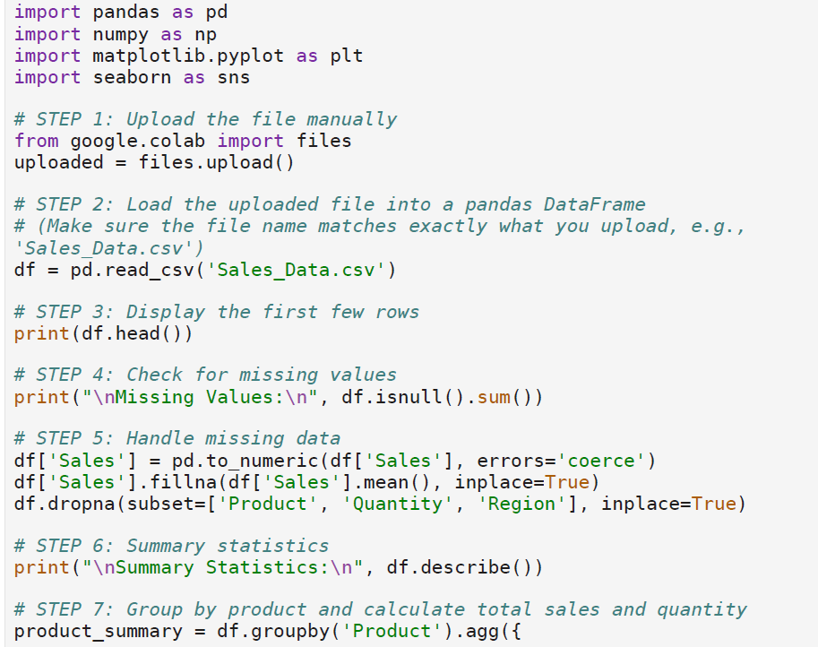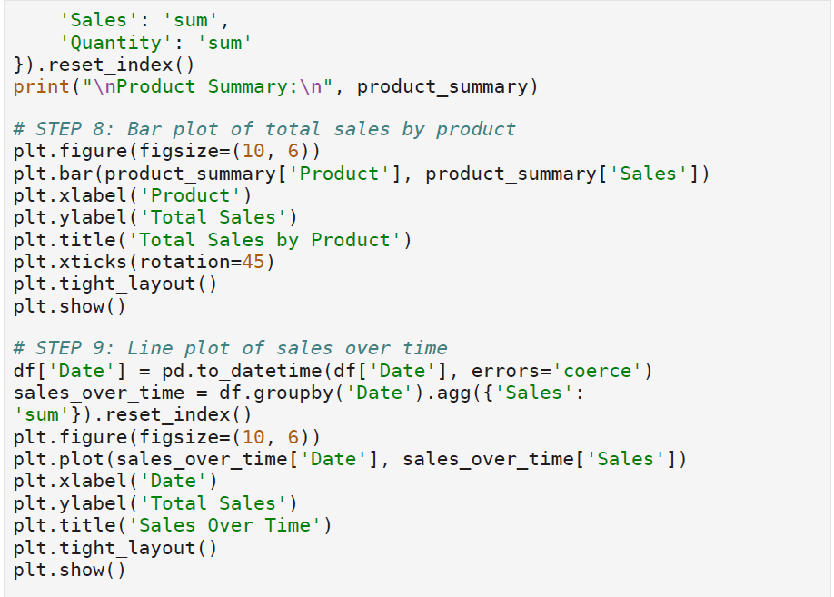

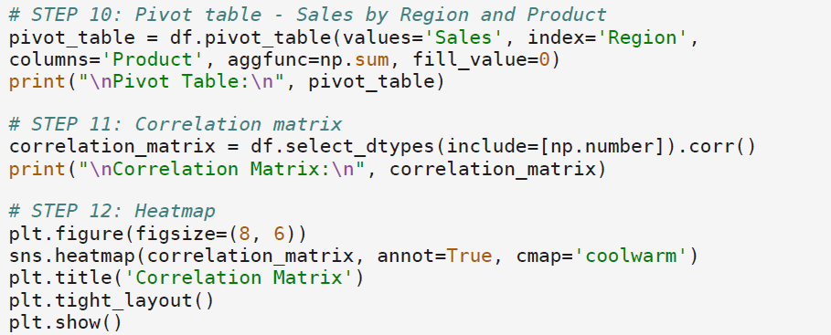

Output:
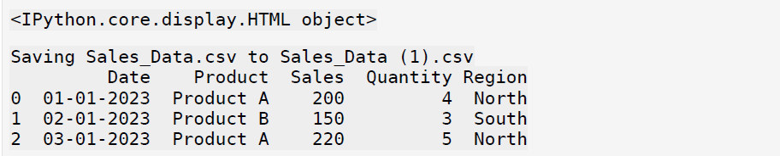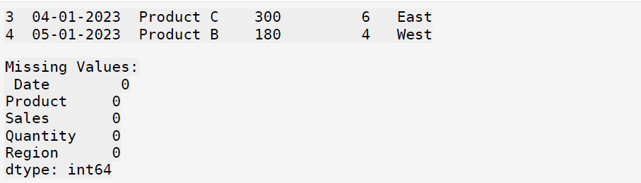

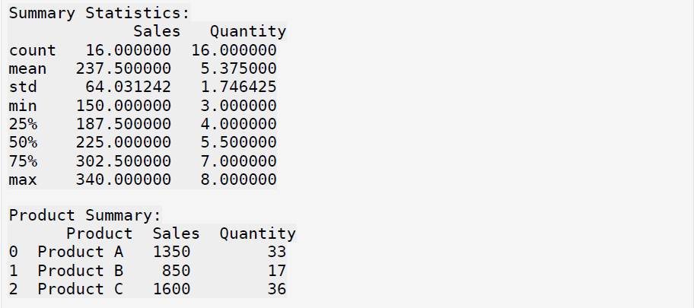

Bar Plot:

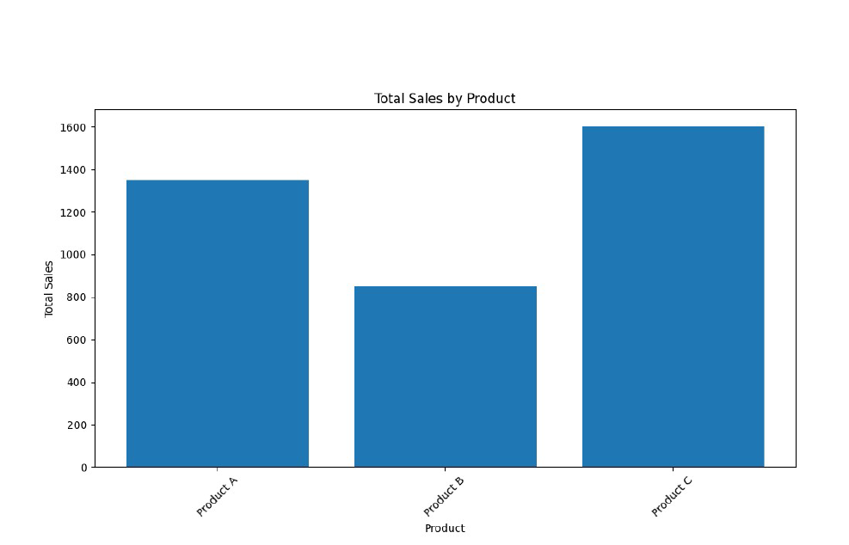

Line Plot:

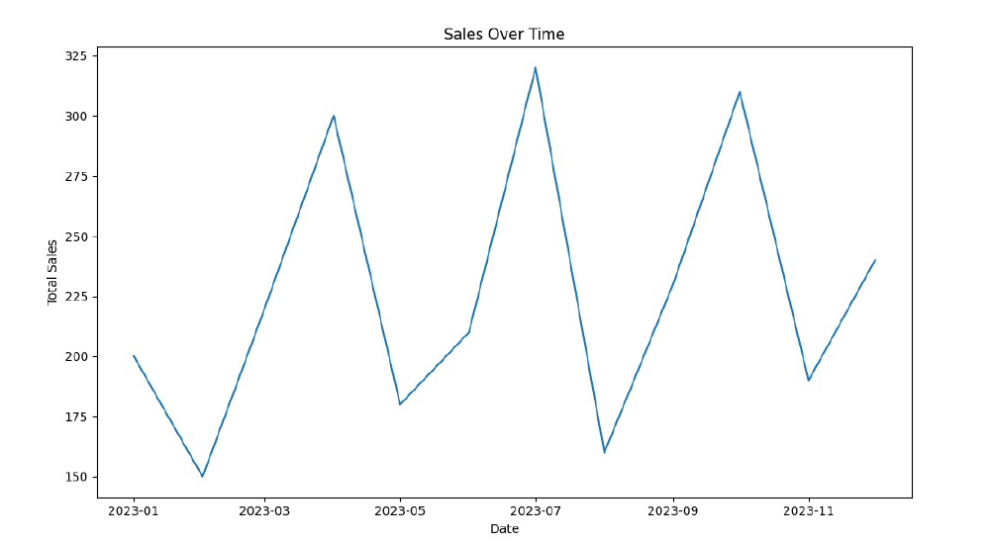

Pivot Table:
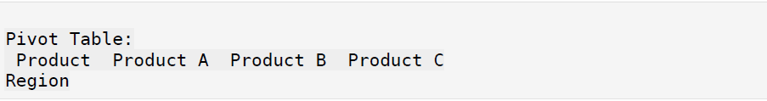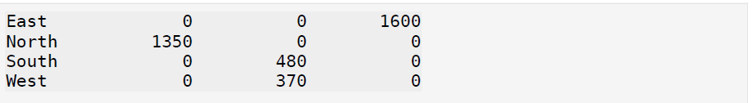

Correlation Matrix:
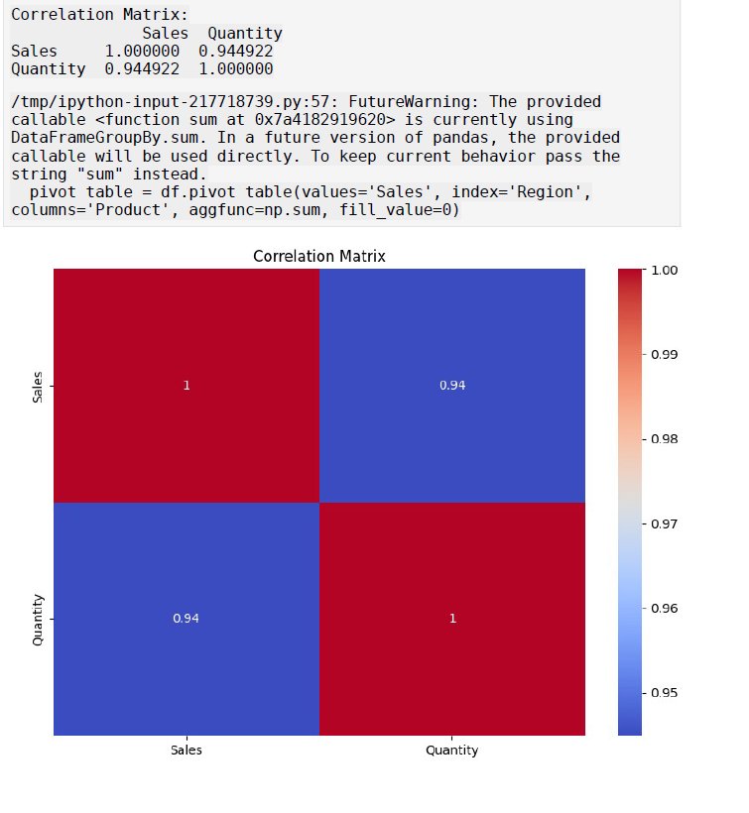
Result:
Thus the given dataset was preprocessed and visualized using a python code.

